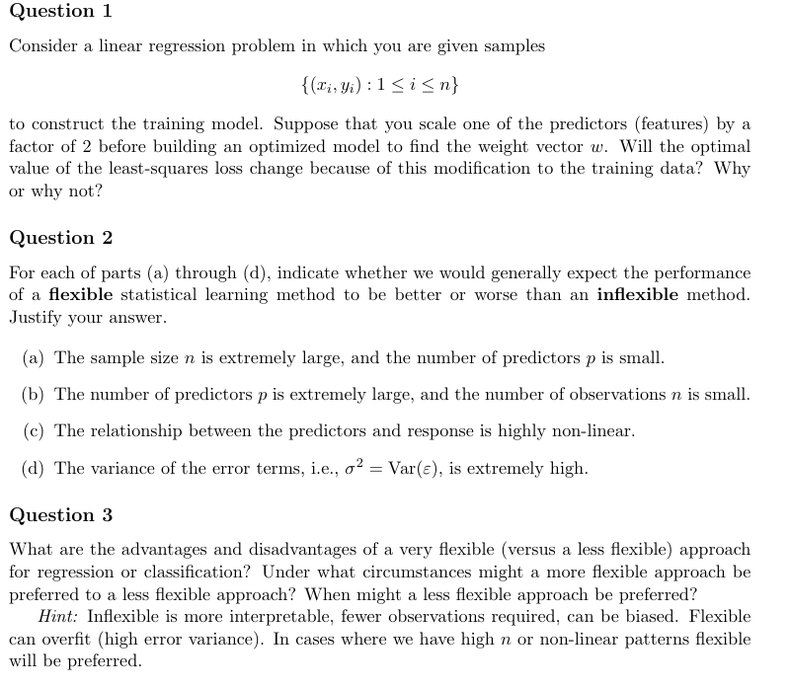
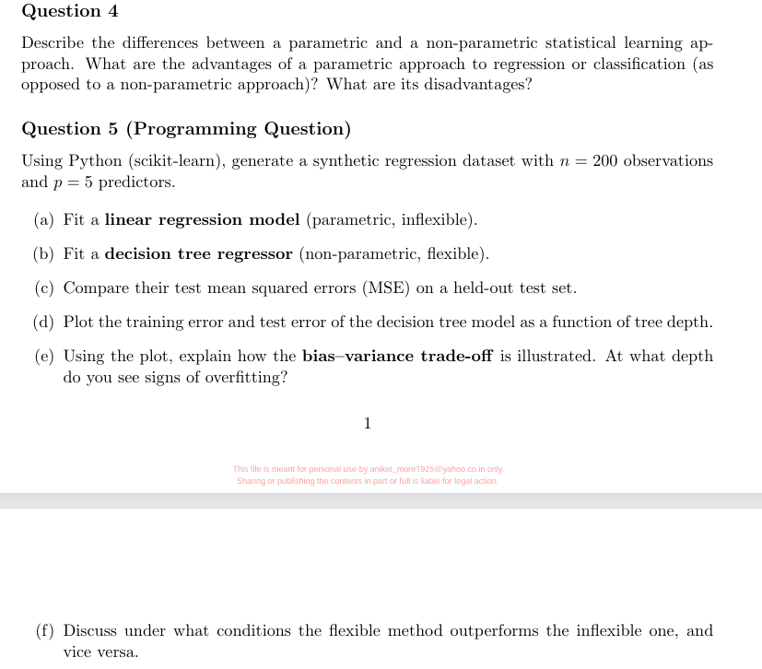

Question 1: Scaling a Feature by 2
Short Answer:
❌ The optimal least-squares loss does NOT change

Why?
Suppose you scale a feature:
$$x_{j}→2x_{j}$$
Then the model:
$$y=w_{j}x_{j}+…$$
becomes:
$$y=w_{j}^{'}(2x_{j})+…$$
To keep predictions same:
$$w_{j}^{'}=\frac{w_{j}}{2}$$

Key Insight:
- Scaling input → weights adjust inversely
- Predictions remain unchanged
- Residuals unchanged → loss unchanged

✅ Conclusion:
$$\boxed{\text{Loss remains the same; only weights rescale}}$$

Question 2: Flexible vs Inflexible Models

(a) Large $n$, small $p$
✅ Flexible is better
Why:
- Plenty of data → overfitting less likely
- Can learn complex patterns safely

(b) Large $p$, small $n$
❌ Flexible is worse
Why:
- High risk of overfitting
- Curse of dimensionality

(c) Highly non-linear relationship
✅ Flexible is better
Why:
- Inflexible models (linear) → high bias
- Flexible models capture non-linearity

(d) Very high noise ($σ^{2}$)
❌ Flexible is worse
Why:
- Flexible models fit noise → overfitting
- High variance problem

✅ Final Answers:
Case | Answer
(a) | Flexible better
(b) | Flexible worse
(c) | Flexible better
(d) | Flexible worse

Question 3: Flexible vs Less Flexible

✅ Advantages of Flexible Models
- Capture complex/nonlinear patterns
- Lower bias
- Better with large datasets

❌ Disadvantages
- Overfitting risk (high variance)
- Require more data
- Less interpretable

✅ Advantages of Inflexible Models
- Simple & interpretable
- Need less data
- Stable (low variance)

❌ Disadvantages
- High bias
- Miss complex patterns

When to use Flexible?
- Large dataset
- Non-linear relationships
- Prediction accuracy > interpretability

When to use Inflexible?
- Small dataset
- Need interpretability
- High noise data

Question 4: Parametric vs Non-Parametric

Parametric Models
Examples: Linear Regression, Logistic Regression
Idea:
- Assume fixed functional form
- Learn small number of parameters

Non-Parametric Models
Examples: Decision Trees, KNN
Idea:
- No fixed form
- Model complexity grows with data

✅ Advantages of Parametric
- Simple & fast
- Less data needed
- Easy to interpret

❌ Disadvantages
- Wrong assumptions → high bias
- Cannot capture complex patterns

✅ Advantages of Non-Parametric
- Flexible
- Capture complex relationships

❌ Disadvantages
- Need more data
- Overfitting risk
- Computationally expensive

Question 5: Programming + Conceptual
a)–(c) Code (Complete)

import numpy as np
from sklearn.datasets import make_regression
from sklearn.model_selection import train_test_split
from sklearn.linear_model import LinearRegression
from sklearn.tree import DecisionTreeRegressor
from sklearn.metrics import mean_squared_error
import matplotlib.pyplot as plt

# Generate data
X, y = make_regression(n_samples=200, n_features=5, noise=20, random_state=42)

# Split
X_train, X_test, y_train, y_test = train_test_split(X, y, test_size=0.2)

# (a) Linear Regression
lr = LinearRegression()
lr.fit(X_train, y_train)
lr_pred = lr.predict(X_test)
lr_mse = mean_squared_error(y_test, lr_pred)

# (b) Decision Tree
tree = DecisionTreeRegressor(random_state=42)
tree.fit(X_train, y_train)
tree_pred = tree.predict(X_test)
tree_mse = mean_squared_error(y_test, tree_pred)

print("Linear MSE:", lr_mse)
print("Tree MSE:", tree_mse)

d) Plot Error vs Depth
depths = range(1, 21)
train_errors = []
test_errors = []

for d in depths:
model = DecisionTreeRegressor(max_depth=d)
model.fit(X_train, y_train)

train_errors.append(mean_squared_error(y_train, model.predict(X_train)))
test_errors.append(mean_squared_error(y_test, model.predict(X_test)))

plt.plot(depths, train_errors, label="Train Error")
plt.plot(depths, test_errors, label="Test Error")
plt.xlabel("Tree Depth")
plt.ylabel("MSE")
plt.legend()
plt.show()

(e) Bias–Variance Tradeoff
Expected plot:
- Training error ↓ continuously
- Test error ↓ then ↑

Interpretation:
- Small depth → Underfitting (high bias)
- Medium depth → ✅ Best
- Large depth → Overfitting (high variance)

Overfitting point:
👉 Where test error starts increasing

(f) When does flexible beat inflexible?
Flexible (Decision Tree) wins when:
- Data is nonlinear
- Enough training data
- Low noise

Inflexible (Linear) wins when:
- Data is linear
- Small dataset
- High noise

Final Takeaways
- Scaling features → does NOT change loss
- Flexible models = low bias, high variance
- Inflexible models = high bias, low variance
- Optimal model = bias–variance balance

